**Sliding Door Wheel Replacement Procedure**

Tools Required:

1. Metric Allen Keys
2. Phillips Head Screwdriver – Large
3. Hammer
4. Punch

Procedure:

1. Remove door from track and support both glass panels (eg lie on salon table)
2. Remove 3 phillips head screws from rear aluminium door frame. (centre screw is under plastic plug). These can be difficult to remove due to corrosion, so I suggest coating the screws with Corrosion-X, WD40 or similar to protect them.
3. Remove rear door frame
4. Loosen set screw on both door carriages and slide them out of the bottom channel.  
   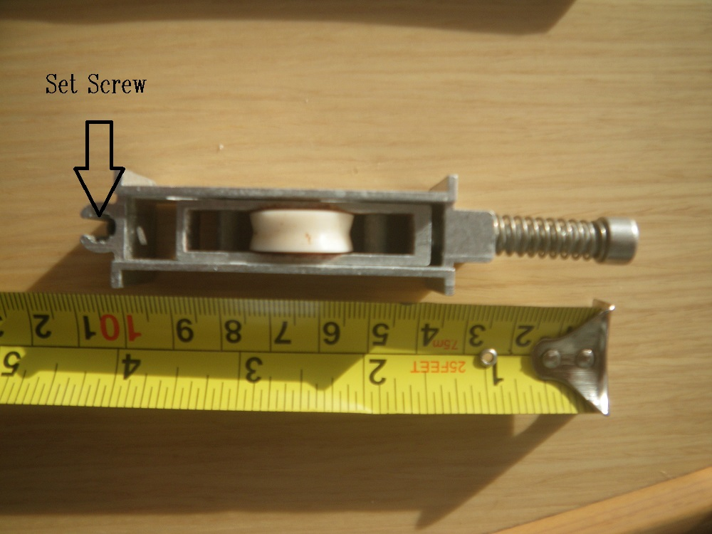
5. Remove the inner adjustable carriage from the outer. To do this, support the outer carriage on blocks at each end in the upright position so that the inner carriage is not supported. The blocks should be at least half the height of the carriage.   
   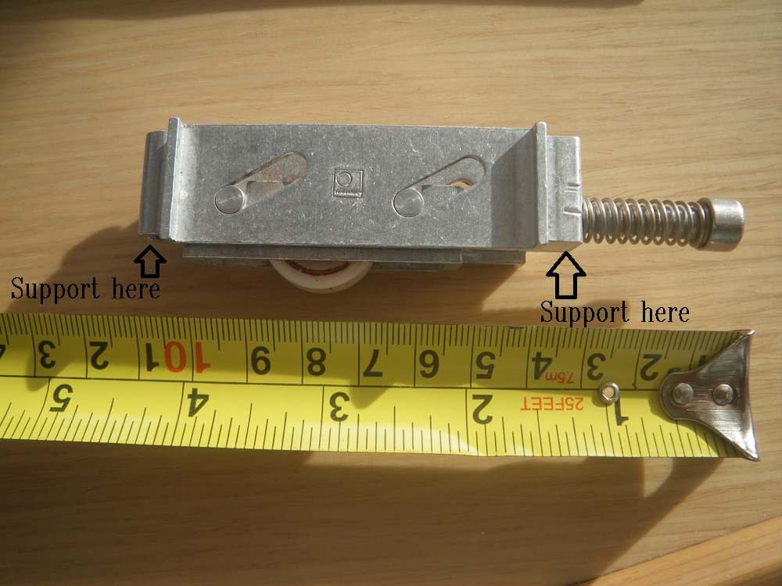  
   With a suitable size punch tap the inner carriage down until it is free of the pins
6. With the inner carriage out of the outer, the wheel axle will be accessible. Lay the inner carriage on it’s side on the blocks so that there is space underneath the axle. Punch this axle through and out of the carriage.
7. Replace the wheel and press the axle back into the carriage
8. Insert the inner carriage in the outer carriage. From the side slots put the two grooved pins back in the outer carriage. Support the inner carriage on either side of the wheel and press the pins back into position in the slots in the inner carriage.
9. Slide the carriages back into position in the lower door frame and tighten set screws.
10. Reassemble door, lubricating the stainless steel screws.